109062318簡弘哲

1. Stack changes before and after ThreadCreate call

According to .map file, the address of _ThreadCreate is 0084, so I set a breakpoint on there. After it stops, I keep pressing step button until SP changes to 0x3F, which is the stack pointer for main.

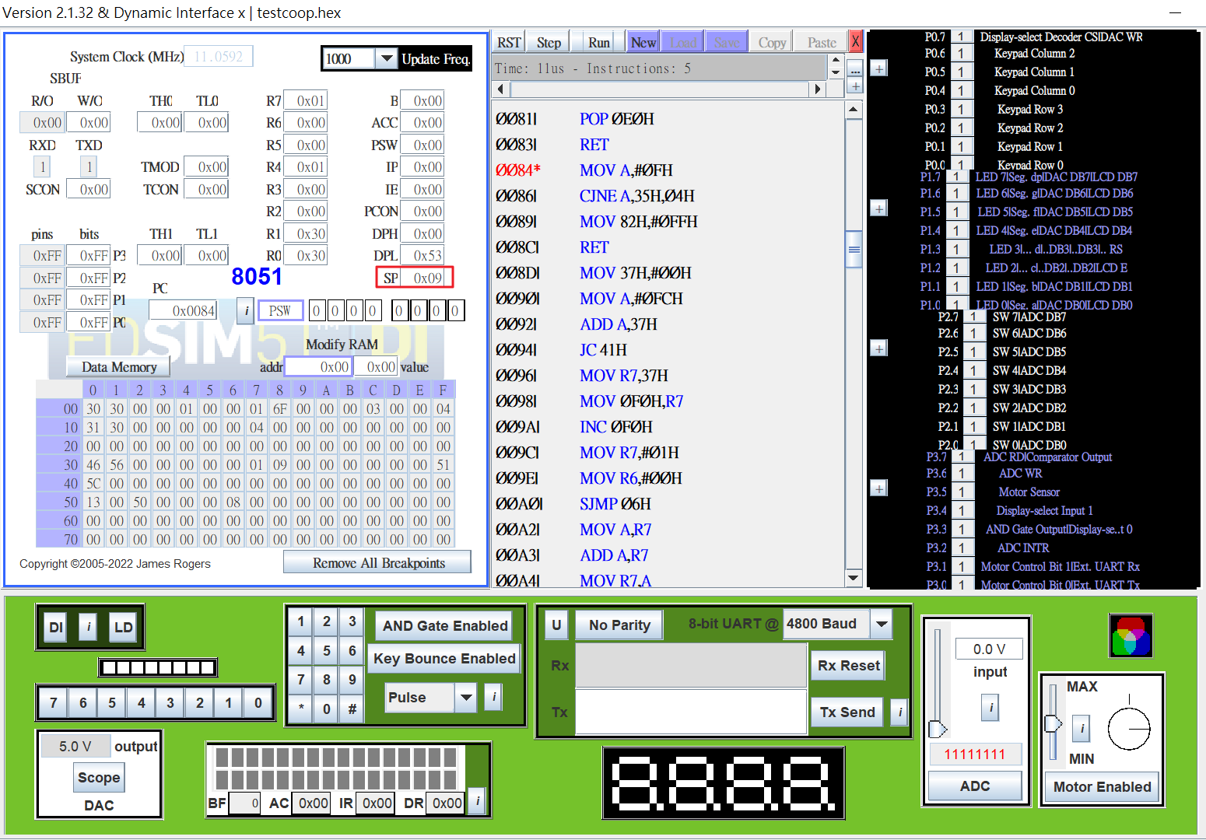

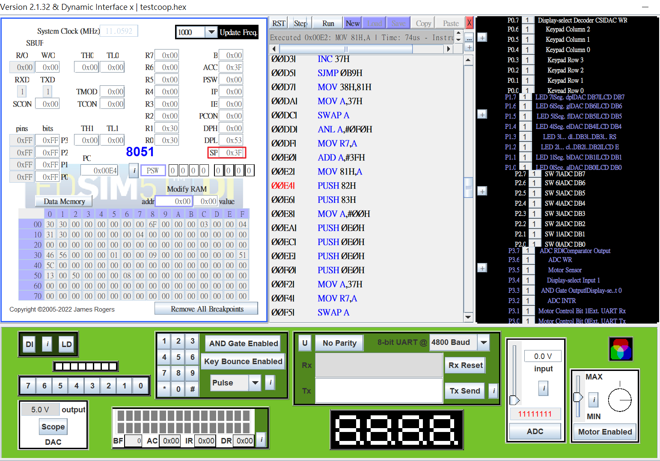

1. Producer running

According to .map file, the address of _Producer is 0009, so I set a breakpoint on there. The red block part(address 001D) is the initialization of Producer, which corresponds to the code ch=’A’ (ch at address 0x3F)

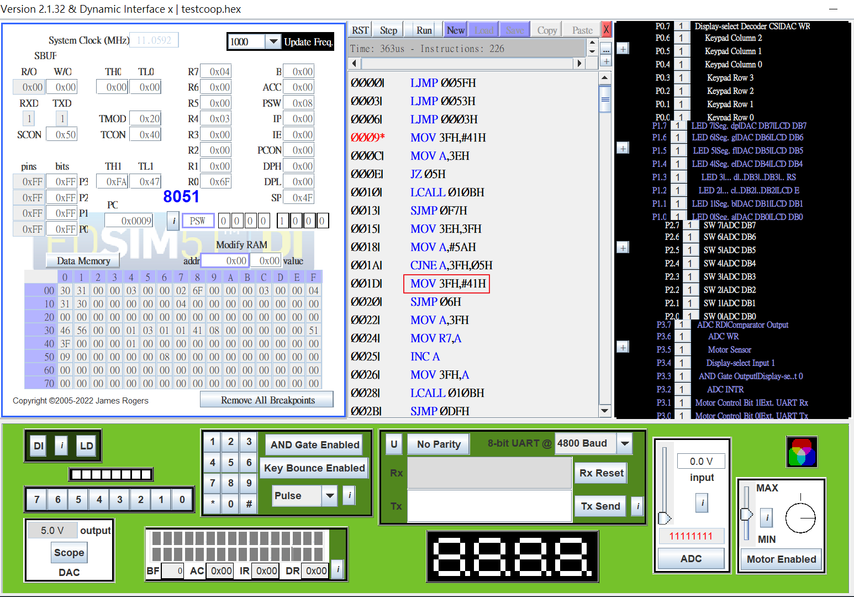

1. Consumer running

According to .map file, the address of _Consumer is 002D, so I set a breakpoint on there. The red block part(address 0041~0044) is the code that I write to SBUF for output

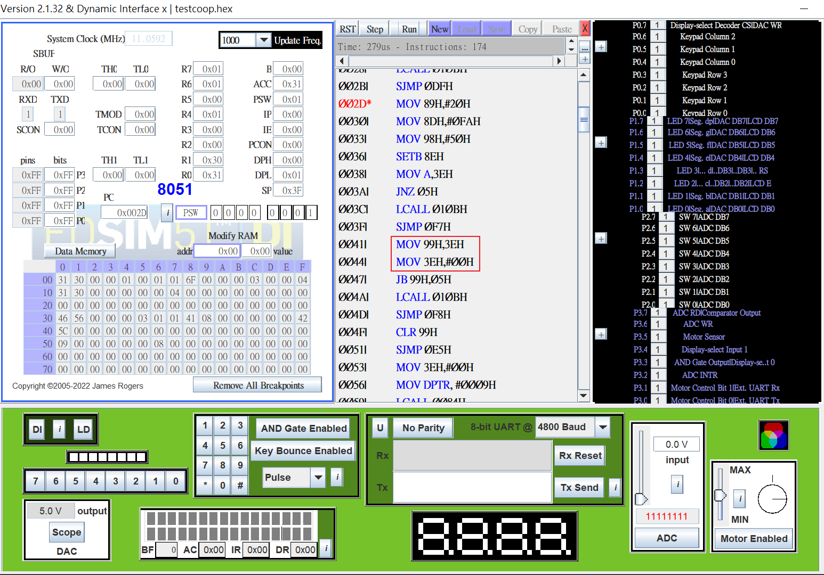

1. Typescript

